River Crossing Game Report

Abdelrahman Khaled -5013

This program is a river crossing puzzle that contains 4 levels each with a different story. The aim of the game is to move all characters on the left bank to the right bank given certain restrictions for each game. The user first is faced with the main menu where he chooses whether he wants to play a new game or load a saved game.

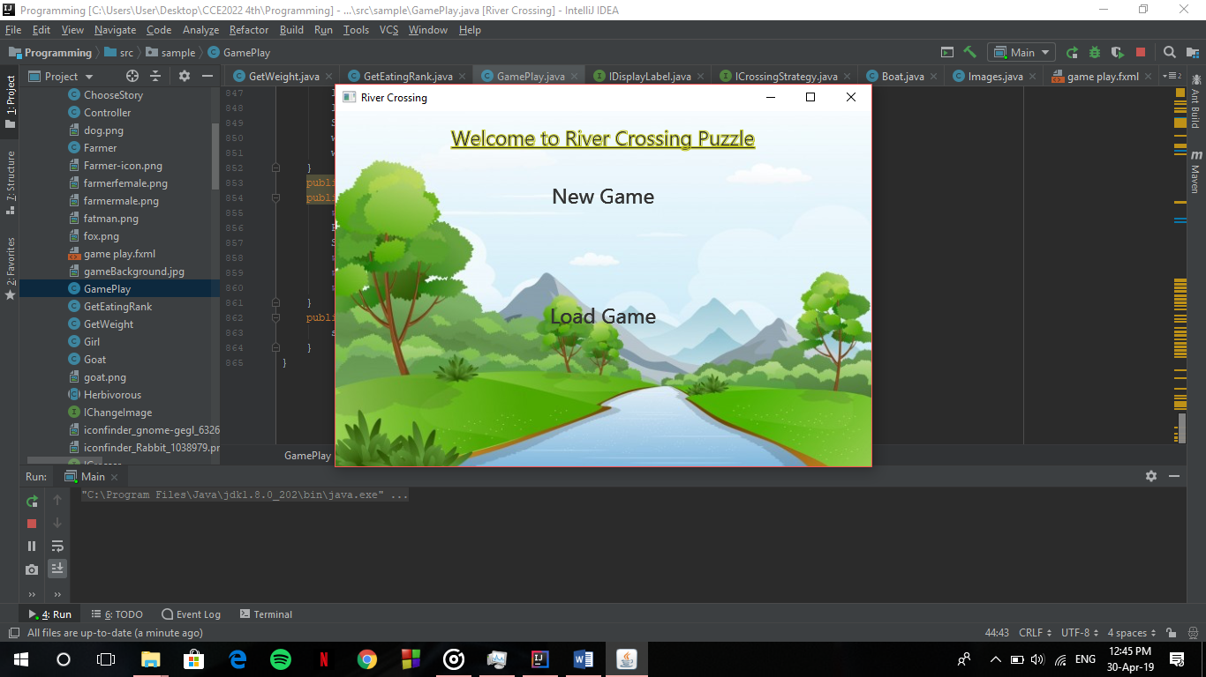

Depending on the users choice he enters a new game or the data from the saved game is loaded and then he chooses the story he wishes to play/continue.

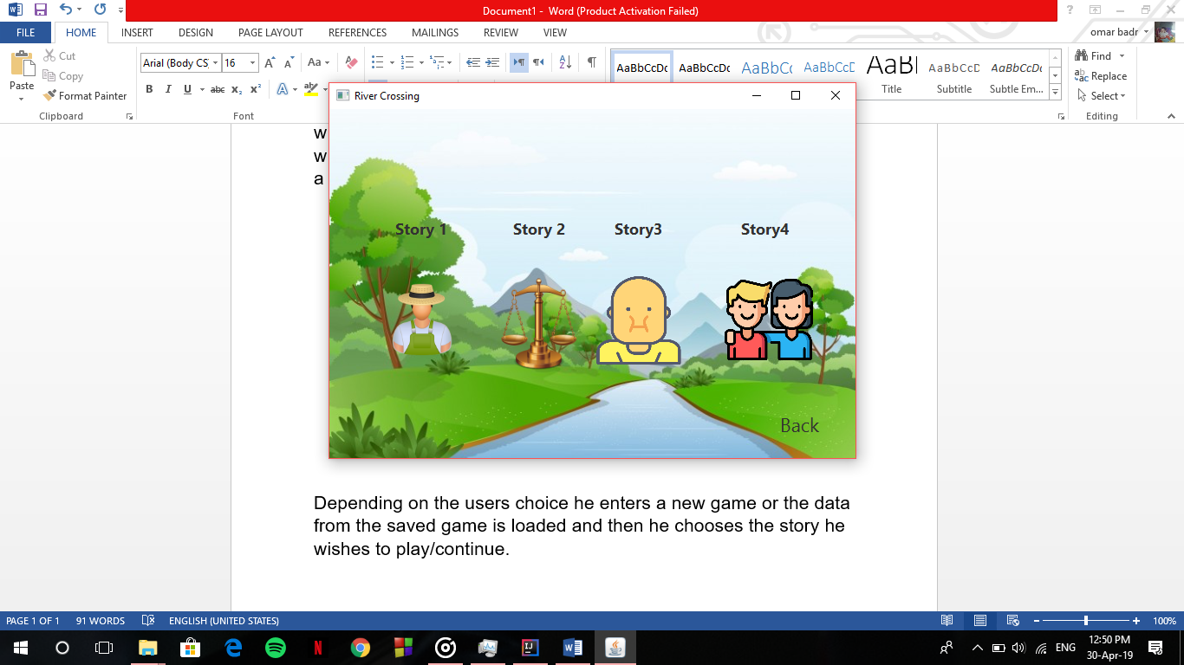 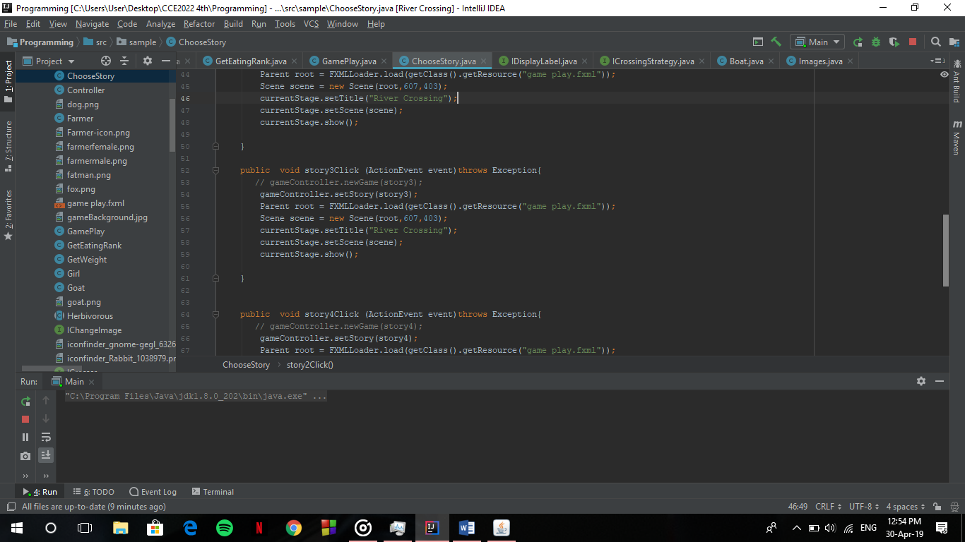

After the user chooses the story he wishes to play the images of the given story is generated and the game starts.

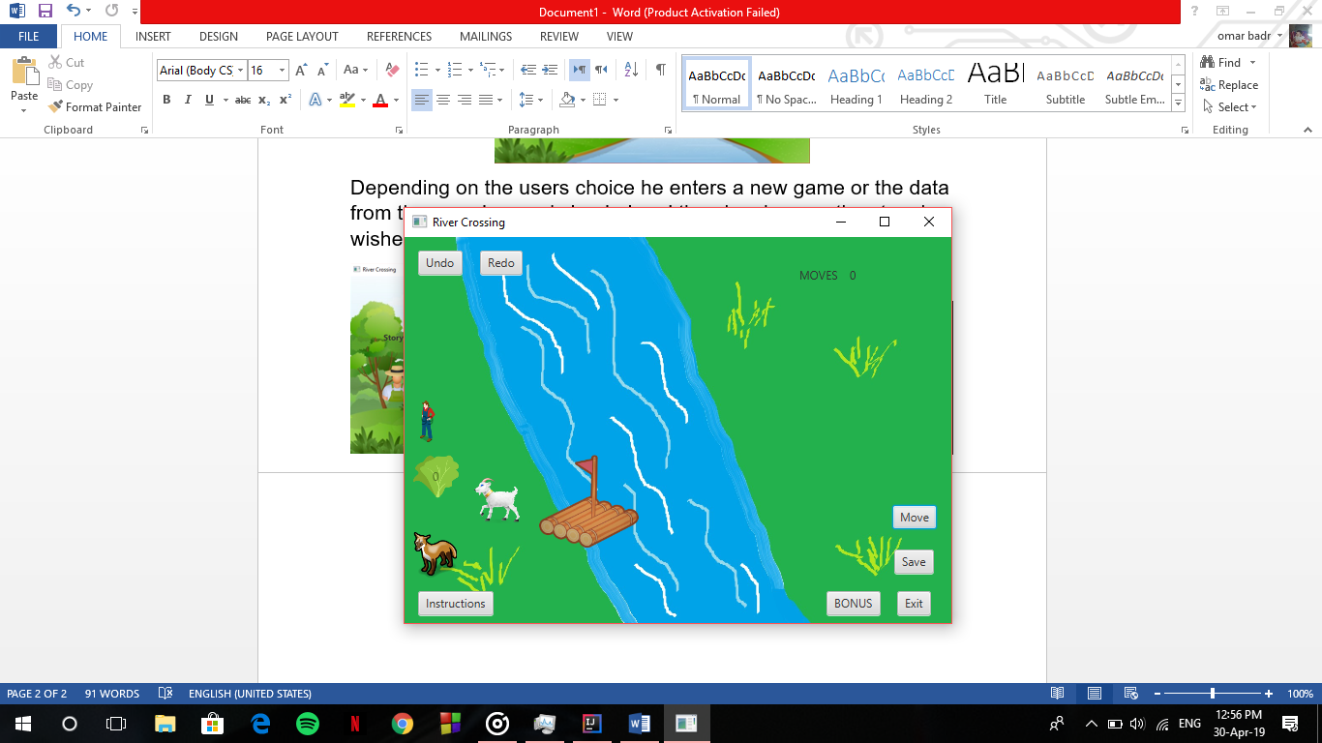

The user first must read the instructions for him to understand how the game works, then the game begins.

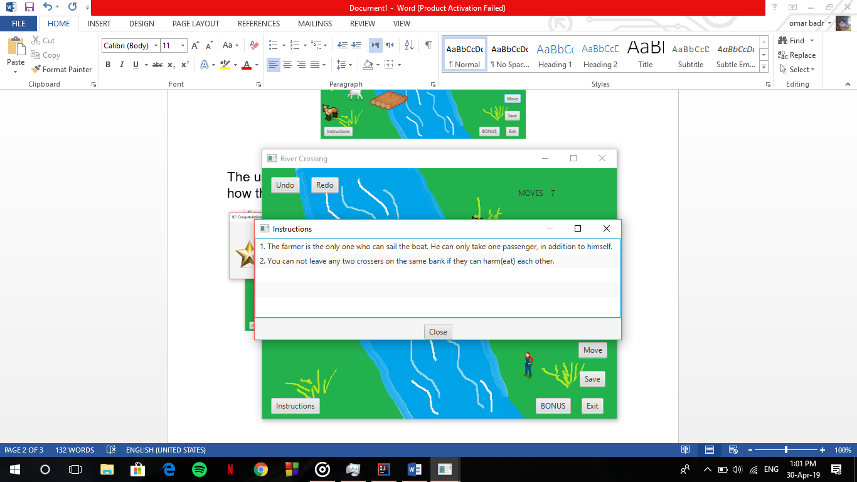

**Game Characters**: are the clickable images that appears on the left bank, once clicked on, the images is moved on the raft waiting for the user to press move.

**Move**: the move button is clicked once the user has put the game characters he wish to move to the right bank, but before the move is done methods check if the move is valid or not. If valid the raft is seen moving from the left to the right and dropping the characters onto the bank. If not valid a pop-up error message is shown to the user

**Undo/Redo**: undo button is used whenever the user does any wrong move and he wishes to go back the the previous move. Redo is then used after the undo button is pressed if he wishes to go back again.

**Save**: saves all the data from the game into a file so if the user wishes to complete it later he can load it from the main menu.

**Exit**: returns the user to the main menu without saving his progress.

If the user manages to win the game he is congratuated with a new window and the number of moves he managed to win the game with determines the number of stars he gets.

